**Ayesha Zubair**

**52916**

**OS Lab 3**

**Creating the Directory Structure**

**Books Directory**

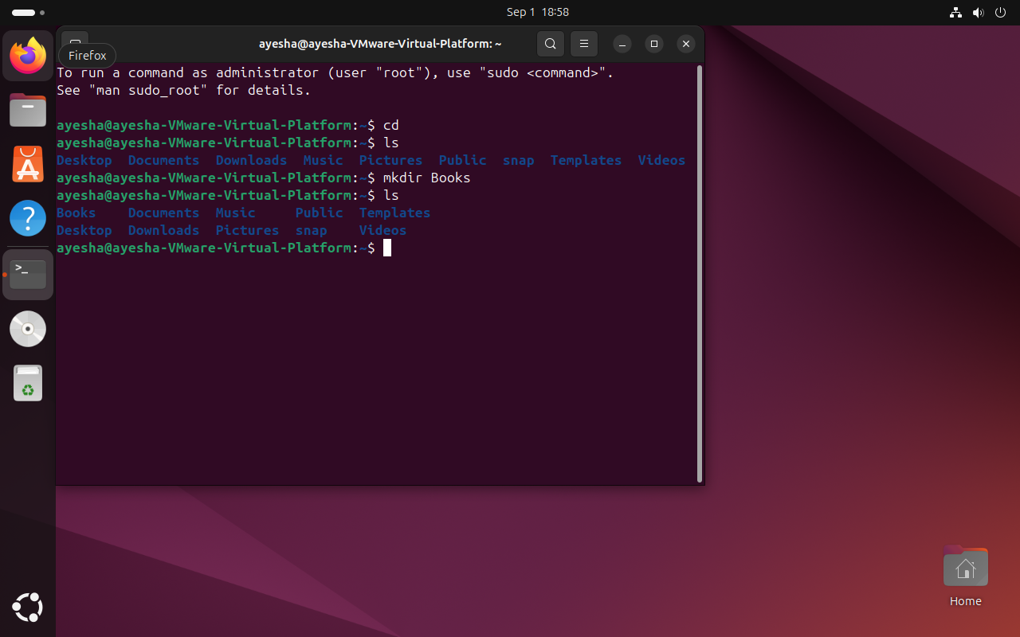

**Creating Directories: Math, Physics and Computer**

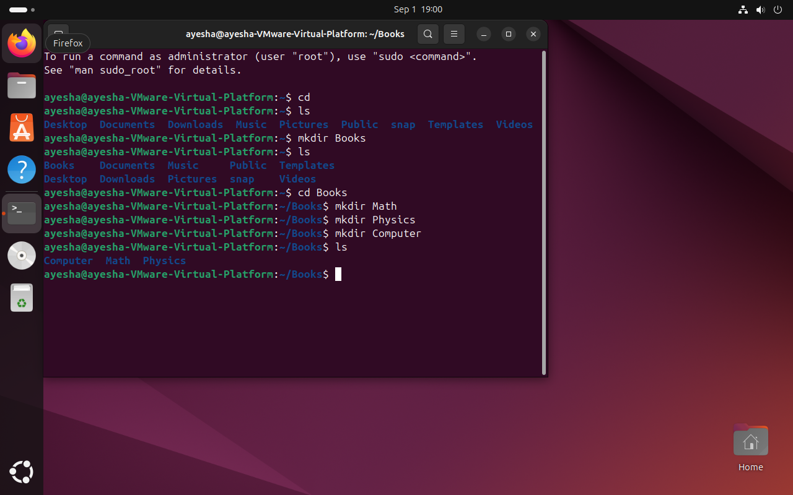

**Creating subdirectories:**

**(For Math)**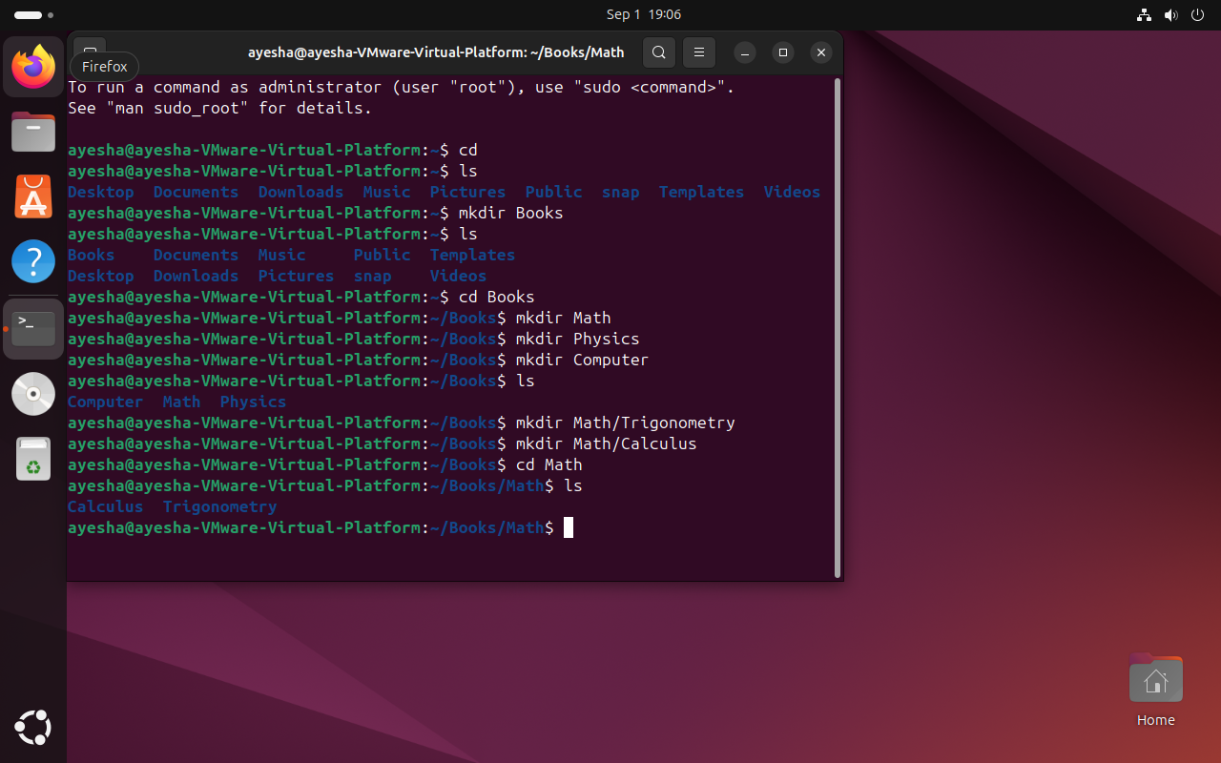

**(For Physics)**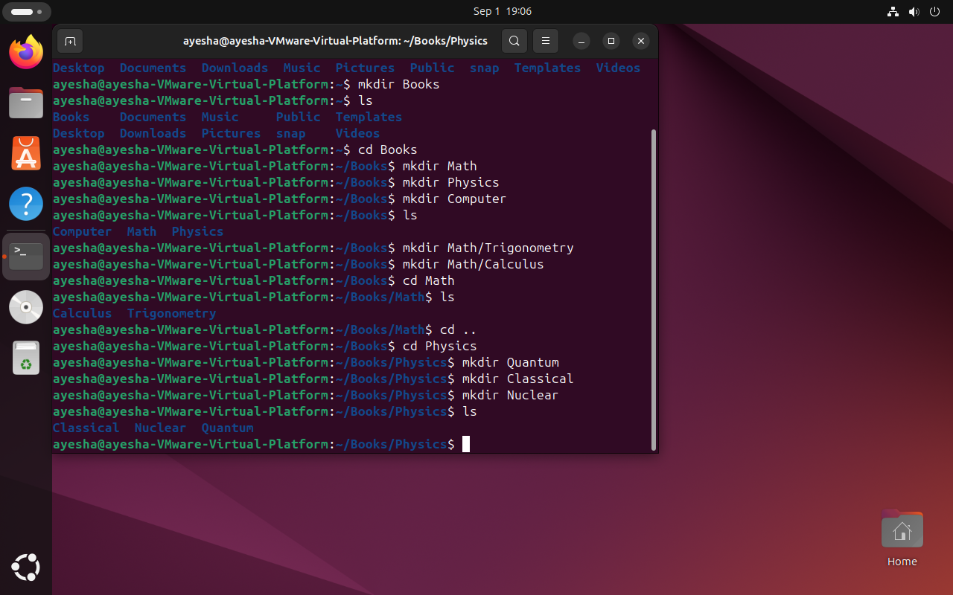

**Task 1: Creating Directory named Chemistry under Books**

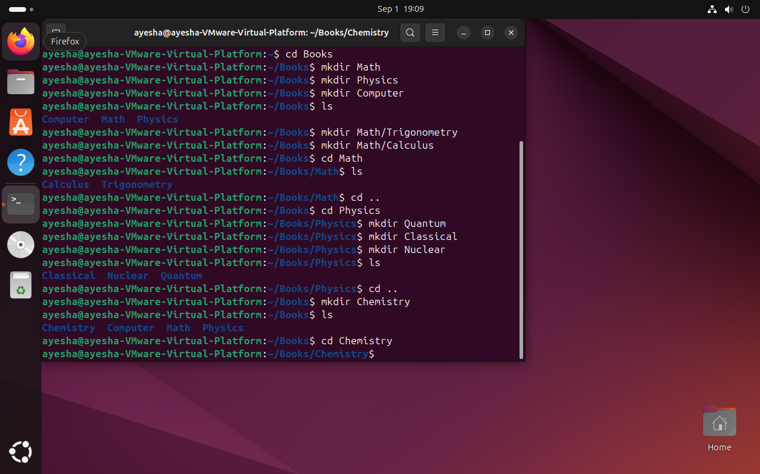

**Go to Home directory directly from Chemistry:**

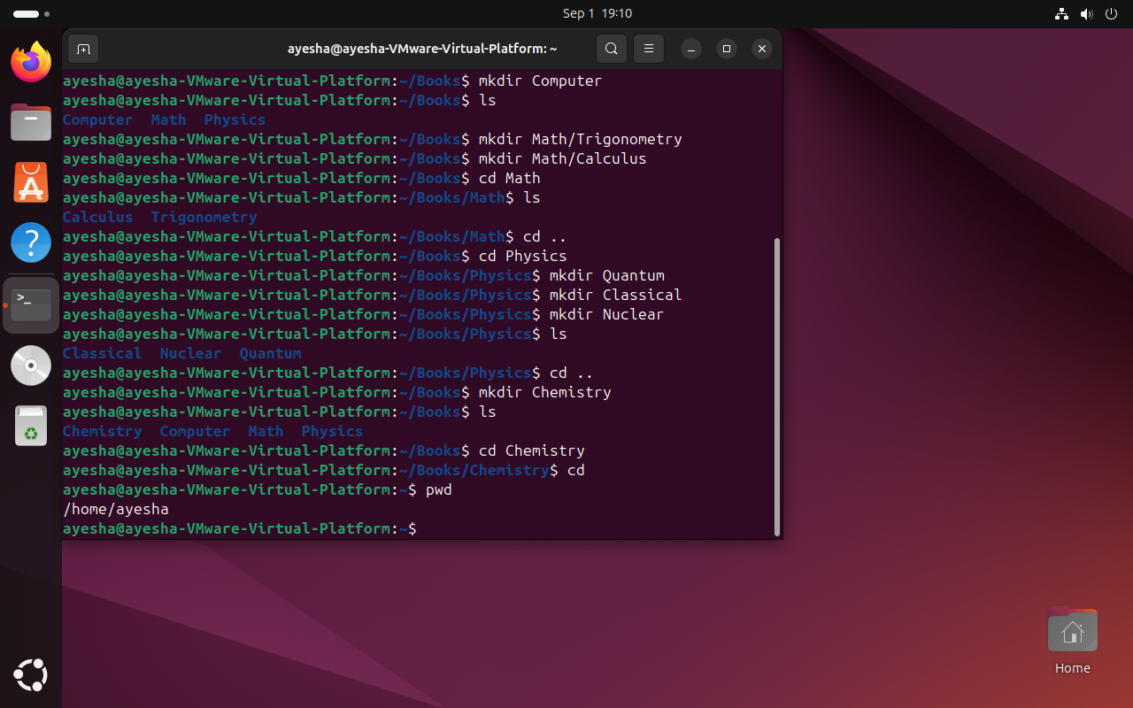

**Task 2: Going to Chemistry Directory directly:**

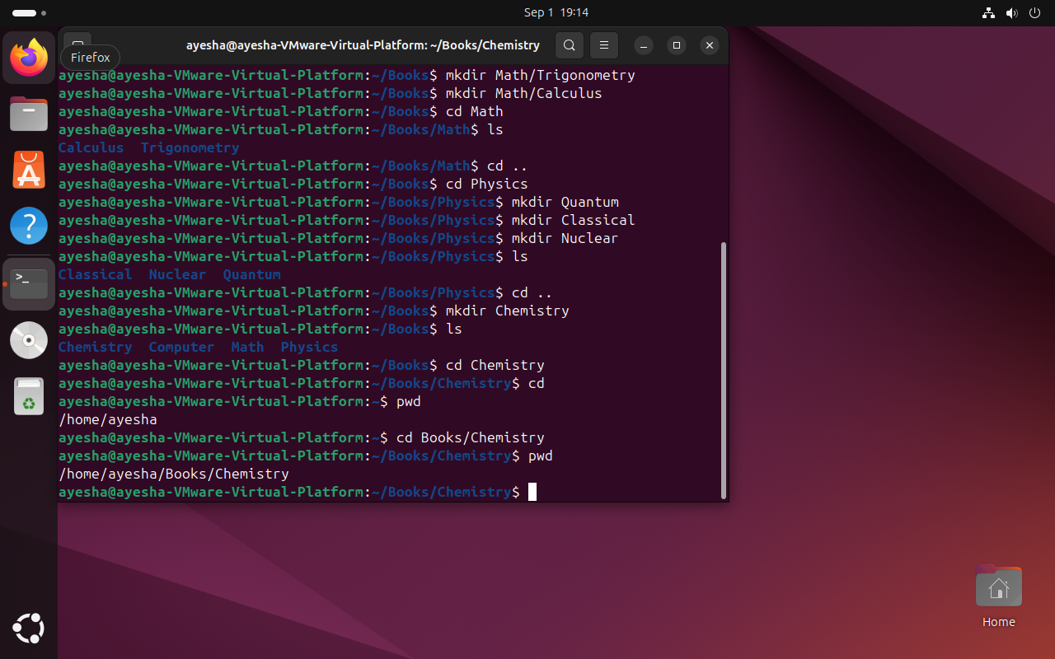

**Question: What do you think books/chemistry is relative or absolute path?**

**Ans:** books/chemistry starts from home directory. Absolute directory path always starts from root directory and since books/chemistry is starting from home directory, so it is relative path.

**Task 3:** How will you add a directory **graphics** under the directory computer while you are in **physics**’ subdirectory **classical**?

**In physics classical:**

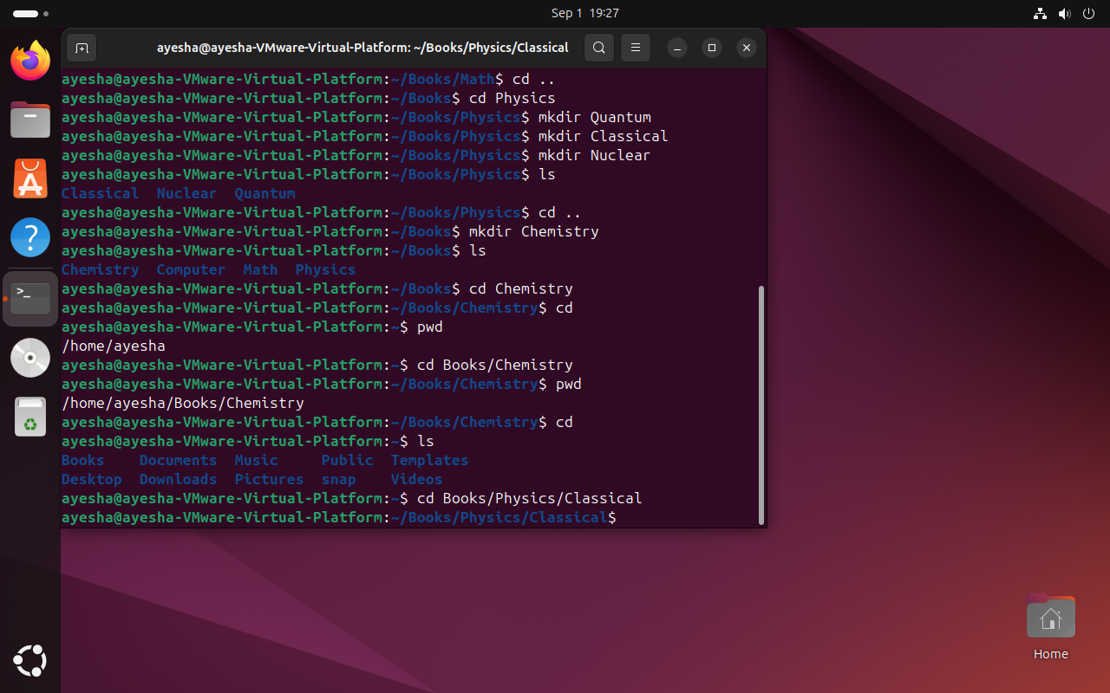

**Creating directory Graphics in Computer**

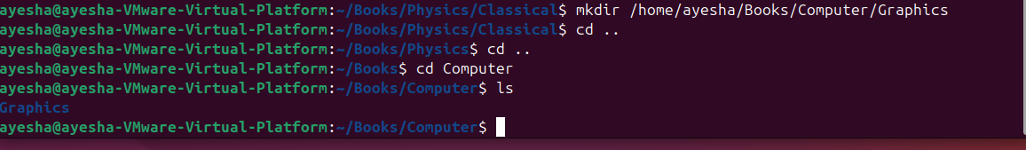

**Task 4: You are in books directory, from here try to remove sub-directory quantum under the directory physics. Now move to directory computer, from here remove sub-directory calculus under the directory math.**

**Removing sub directory quantum under physics while being in Books:**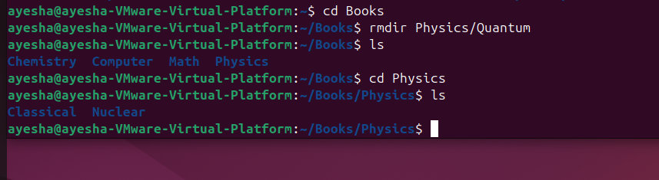

**Now move to directory computer, from here remove sub-directory calculus under the directory math.**

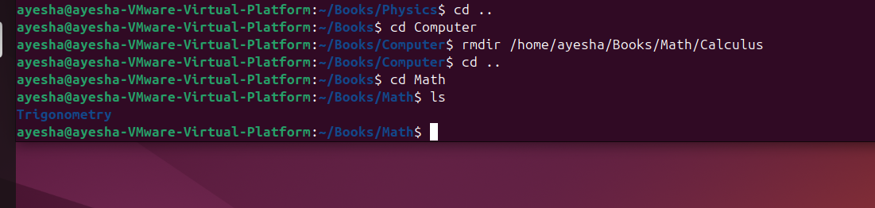

**Task 5: Which are the Linux Directory Commands? Explain the understanding of commands in your own words.**

Linux directory commands are used to navigate different directories and subdirectories. They are also used to create or remove directories and subdirectories.

Some linux commands are:

Pwd: it gives the path of the directory in which we are currently present

Ls or dir: lists down all the files present in a directory

La –a: lists all the files, even the hidden files

Ls –l: displays all the files with its details, for e.g. date created

Ls –r: lists all the files in reverse order

Cd: command used to change directory

Cd : command that takes to home directory

Cd/: command that takes to root directory

Cd .. : command that takes to parent directory (1 directory above in a hierarchal structure)

Mkdir: used to create a directory or subdirectory

Rmdir: used to remove a directory or a subdirectory

Rm –r: this command is used to delete a directory when it is non empty.